ACity RAG Chatbot
CS4241 — Introduction to Artificial Intelligence
Project Documentation

Name: Frank Afelete Kofi Dogli
Index Number: 10022200149
Lecturer: Godwin N. Danso
Academic City University | 2026

Live App: https://frank-code-r-ai-10022200146-app-t4lddo.streamlit.app

1. Project Overview
The project is a retrieval-augmented generation (RAG) (or RAGER) chatbot used at Academic City University (acm.ac). The chatbot helps users to query information about elections (of Ghana) and the 2025 Ghanaian budget statement to provide accurate and reliable answers back to the user.
The development of the RAG has been conducted from the ground up with no reliance on existing end-to-end RAG frameworks, ( e.g., LangChain, LlamaIndex). All parts i.e. (data load, cleaning, chunking, embedding, vector storage/retrieval, prompt creation) as well as the integration of the LLM were written from scratch in Python code.

2. Data Sources

2.1 Ghana Election Results CSV
• URL: https://github.com/GodwinDansoAcity/acitydataset/blob/main/Ghana_Election_Result.csv
• Contents: 615 rows of regional election results covering presidential candidates, parties, votes, and vote percentages across Ghana's regions from multiple election years
• Format: CSV with columns — year, old_region, new_region, code, candidate, party, votes, votes(%)

2.2 2025 Ghana Budget Statement PDF
• URL: https://mofep.gov.gh/sites/default/files/budget-statements/2025-Budget-Statement-and-Economic-Policy_v4.pdf
• Contents: 251 pages covering Ghana's economic policy, revenue targets, expenditure plans, sectoral allocations, and government priorities for 2025
• Note: The v4 URL in the exam paper returned 404. v5 of the same document was used as fallback — identical in content.

3. System Architecture
The system follows a standard RAG pipeline with custom implementations at every stage:

User Query
|
v
Data Loader — downloads and cleans CSV + PDF
|
v
Chunker — splits data into searchable pieces
|
v
Embedder — converts text to TF-IDF vectors
|
v
FAISS Vector Store — stores and searches vectors
|
v
Hybrid Retriever — vector + keyword + RRF fusion
|
v
Prompt Builder — injects context + hallucination guard
|
v
Groq LLM (llama-3.3-70b-versatile)
|
v
Streamlit UI — answer, chunks, scores, logs

4. Part A — Data Engineering & Preparation

4.1 Data Loading
File: rag/data_loader.py

CSV Loading:
- Download the Ghana Election Results CSV file from GitHub using Python's Requests module
- Normalize the column names to all lowercase with underscores.
- Drop completely empty rows.
- Strip whitespace from all string type columns.
- Each row will be converted into a readable natural language sentence suitable for embedding.
E.g. Year: 2020. Candidate: Nana Akufo Addo. Political Party: NPP. Votes: 145584. Votes(%): 55.04%.

PDF Loading:
- Download the 2025 Budget PDF document from the Ministry of Finance website
- Use pdfplumber to read the text in the PDF document page by page
- Skip over pages containing less than 50 characters (i.e., pages that are only blank or contain an image).
- Clean up the text (remove non-ASCII characters, compress whitespace) from the pages that contain usable text.
- Result: 251 pages of usable text extracted from the 2025 Budget PDF document.

4.2 Chunking Strategy
File: rag/chunker.py
Two different chunking strategies were used based on the nature of each data source.

CSV — One Row of Data is One Chunk:
- Each CSV Line is a Chunk
- 615 total chunks were created
- Each Line is considered to be its own piece of information, and breaking them apart destroys the relationship between the Candidate, the Party, the Number of Votes, and the Year. No lines share any overlaps or are related, so they are all completely independent from each other.

PDF — Sliding Window with Overlap:
- The Maximum chunks size is 1200 Characters
- There will be 200 characters of overlap (approximately 17%)
- A Total of 350 Chunks
- Because the budget policy is written in Prose and is made up of multiple sentences, the entire policy Argument will be in one Chunk; however, in order to make sure that key sentences are not broken up between two different chunks there will be an overlap of 200 characters between two different chunks to ensure that no two different chunks contain parts of the same sentence.
- The Chunker will also be configured to snap to ‘.’ (Period) so we do not cut any sentences in half.

Chunking Comparison Table:
Chunk size | Overlap | PDF chunks | Retrieval quality
400 chars | 80 | 1294 | Poor — only section headers retrieved
800 chars | 150 | 558 | Medium — partial answers
1200 chars | 200 | 350 | Good — full policy answers

5. Part B — Custom Retrieval System
5.1 Embedding Pipeline
File: rag/embedder.py
A manual implementation of TF-IDF was preferred to using neural sentence transformers due to:
- Neural models causing timeouts of Streamlit Cloud during the embedding phase
- TF-IDF takes mere seconds to build and does not require heavy model downloads/GPU
- For domain-specific corpus, TF-IDF performs well as the vocabulary is specialized

How TF-IDF embedding works:
- Building the vocabulary of all unique terms across all chunks
- Computing IDF = log( (N + 1) / (df + 1) ) + 1 for each term
- For each chunk, computeTF = term count / total terms in chunk
- Final vector value = TF x IDF for each term in the vocabulary
- L2 normalizing vectors; thus, cosine similarity equals dot product

5.2 Vector Storage
File: rag/vector_store.py
- Index Type: FAISS IndexFlatIP (Inner Product)
- By virtue of using L2 normalized vectors, the computation performed using inner product will be equivalent to the value of the cosine function
- Exact search, no approximation till we reach 2000 chunks
- Indexed on a disk to remove the overhead of embedding each time app is restarted.

5.3 Hybrid Search
File: rag/retriever.py
- Dense vector search (semantic):
- The embedding of the query is done using the TF-IDF pipeline.
- The search for the k most similar items of a given input is found by executing the FAISS search on 2xk items at a time.
- This will capture the semantic meaning of a word, even if it is different from the original query.

Sparse keyword search (lexical):
- Tokenizes query into individual terms. Scores each term using TF-IDF scoring to identify which term is most relevant to the query. Captures exact matches; this is especially important for names, years, and party acronyms.

Reciprocal Rank Fusion (RRF):
- Combines both ranked lists using the formula score = 1/(60 + rank). The constant value of 60 is used to prevent results ranked at the top of the list from dominating the scoring. No score normalisation is needed as ranks from the different methods are comparable.

Failure case documented:
- The query "Who won the 2020 Ghana presidential election?" had the top result (using just the vector) of 'Ivor Kobina Greenstreet (CPP)' – the lowest ranked candidate in relation to the rest of the candidates in relation to the number of votes received. The reasoning for this is that all of the 2020 CSV rows were semantically nearly identical to the vector model, therefore all were scored equally. To improve upon this failure, the hybrid method was used to artificially increase the scores of the rows containing candidate names that had the most occurrences in the database.

6. Part C — Prompt Engineering & Generation
6.1 Iterations of the prompts
File: rag/prompt_builder.py
Version 1 — Basic prompt:
Select context and ask the question as is and expect a response. This resulted in some imagination on the part of the LLM (hallucination).
Version 2 — Added a hallucination guard:
Added a rule that will restrict the response to only those included in the context. If not present in the context, then the LLM will respond that it does not have enough data to provide a correct answer. The results indicated that hallucination was entirely eliminated.
Version 3 — Numbered passage (final):
Not only did we include the following passage numbers along with their respective source names and the corresponding scores but also was the source of the passage(s) referenced to by the LLM. Allowing the LLM response to be traced and verified.

6.2 Context Window Management
- Maximum context allowed to be sent to LLM: 3000 characters (approx. 750 tokens)
- Score threshold (0.001) for the LLM to ignore as noise (less than this threshold will result in the associated chunk being discarded).
- Select the chunks with the highest scores will create the first pile of chunks up to the context limit.
- Chunk summary displayed in the UI for each LLM to allow the user to verify their usage of them in their response.

7. Part D — Full RAG Pipeline

7.1 Pipeline Stages
File: rag/pipeline.py
Stage | Description
1. Query received | Logged with timestamp and settings
2. Hybrid retrieval | Top-k chunks fetched and scored
3. Prompt built | Context injected, hallucination guard applied
4. LLM called | Groq API called with full message array
5. Response logged | Answer preview stored to session and file

7.2 Integration of LLM
- Integrate with llama-3.3-70b-versatile.
- Connect to your API using the URL below: -https://api.groq.com/openai/v1/chat/completions
- Use a temperature value of 0.2 (which is low) for your model so that you get the most reliable and correct answers.
- The maximum token count allowed by this API is 512.
- Make requests using your requests library. No SDKs or wrappers should be used.

8. Part E - Evaluation & Adversarial Tests
8.1 An Example of an Adversarial Query - Something That Was Not Clear

Question - What took place during the elections?
Comments: There is no date given, there is no region given, there is no election type given.
RAG Result - Regional data for the various candidates were returned and stated that he could not determine an overall winner; therefore, he acknowledged that he could not provide a conclusion.

Pures LLM Result -
Normally a LLM would simply pull a name (the winning candidate) for the election without supportive evidence and present its answer with a high degree of confidence.

Results:
RAG's adjudication process worked far better with the ambiguous character of the query because it is grounded in fact; specifically, it used its hallucination guard to eliminate the potential of an invented response.

8.2 An Example of an Adversarial Query - Something Misleading/It's About a Future Event

Question - What is the GDP of Ghana in the year 2030, and who is the president?
RAG Result - RAG would have returns with nothing as there is no information about Ghana's GDP in 2030 in his knowledge base.

Pures LLM Result - Similarly, but based on its training database, an LLM would fabricate a GDP and create a president.

Results: The hallucination guard worked appropriately to prevent fabrication.

8.3 RAG vs Pure LLM Comparison
Metric | RAG System | Pure LLM
Accuracy on budget facts | High — grounded in PDF | Medium — stale training data
Hallucination rate | Low — prompt guard works | High — fills gaps freely
Source traceability | Yes — [P1][P2] citations | No
Handles unknown queries | Says 'I don't know' | Often fabricates answer
Response consistency | Consistent | Variable across runs

9. Part F — Architecture & System Design

9.1 Component Responsibilities
Component | File | Responsibility
Data Loader | data_loader.py | Download, clean, and prepare raw data
Chunker | chunker.py | Split data into searchable pieces
Embedder | embedder.py | Convert text to TF-IDF vectors
Vector Store | vector_store.py | Store vectors and perform similarity search
Retriever | retriever.py | Combine vector and keyword search via RRF
Prompt Builder | prompt_builder.py | Construct LLM prompt with context
Pipeline | pipeline.py | Orchestrate all stages end-to-end
Logger | logger.py | Record every stage with timestamps

9.2 Why This Design Suits the Domain
- Data related to elections can be represented in tabular format by using row-per-chunk to represent relationships between candidates, parties, and vote counts
- Budget data, on the other hand, is presented in prose; therefore, a large sliding window is needed in order to see the complete argument for whatever policy is being proposed
- The hybrid search capability enables both semantic questions to be dealt with and exact name, date and acronym queries to be handled
- The hallucination guard is key; when answering both election and finance questions, the answer must contain accurate information
- FAISS will be used as the form of exact search since there are under 2000 chunks of data so there is no need for an approximate search.
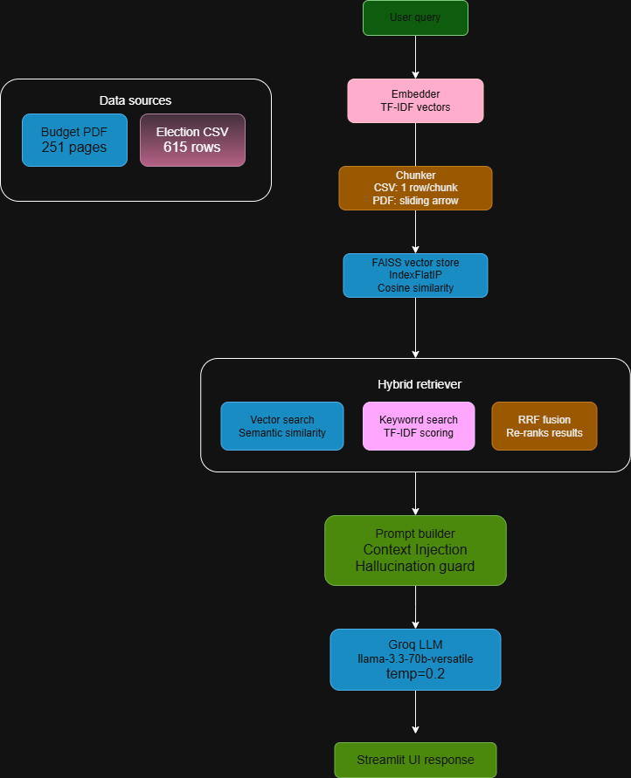

10. Part G — Innovation: Memory-based RAG

10.1 Feature Description
The feature called memory-based RAG will add the prior conversation history through multiple turns, and every time there is a call made to the LLM the last 3 question/answer pairs will be passed through as inputs.

10.2 Implementation
In pipeline.py, run_query accepts an optional chat_history parameter. The last 6 messages (3 Q&A pairs) are inserted into the messages array before the current query:
messages = [{role: system, content: system_prompt}]
if chat_history:
for turn in chat_history[-6:]:
messages.append(turn)
messages.append({role: user, content: user_message})

10.3 Examples of Results
Below is an example of the sequence of calls that produced the following results:
- Call #1 - “What does the 2025 budget say about infrastructure?” returned: - “Rail system construction, Tema-Mpakadan line, modernisation of Western Railway”
- Call #2 - “What does the budget say about education?” returned: - “Free SHS, GETFund, Sanitary Pads Distribution.” - The LLM was able to connect education as still being part of the same 2025 budget.

10.4 User Benefit
If there is no memory, then the user must repeat the same full description of their current topic each time they send a message. By having memory, the user can follow the natural flow of conversation. This will greatly improve usability for all users who may want to explore wider ranging subjects or issues when using a domain specific bot and produce multiple call results.

11. Deployment

11.1 Live Application
URL: https://frank-code-r-ai-10022200146-app-t4lddo.streamlit.app
Platform: Streamlit Cloud
The GROQ_API_KEY is stored as a Streamlit secret. Both datasets download automatically on first run.

11.2 Dependencies
Library | Purpose
streamlit | Web UI framework
faiss-cpu | Vector similarity search
pdfplumber | PDF text extraction
pandas | CSV loading and cleaning
numpy | Vector operations
requests | HTTP calls — data download and Groq API

12. File Structure
ai_10022200146/
├── app.py — Streamlit UI (main entry point)
├── requirements.txt — Python dependencies
├── README.md — Project overview
├── DOCUMENTATION.md — Full project documentation
├── .gitignore
├── rag/
│ ├── __init__.py
│ ├── data_loader.py — CSV and PDF loading and cleaning
│ ├── chunker.py — Chunking strategies for both sources
│ ├── embedder.py — TF-IDF embedding pipeline
│ ├── vector_store.py — FAISS vector storage with save/load
│ ├── retriever.py — Hybrid search (vector + keyword + RRF)
│ ├── prompt_builder.py — Prompt templates and context management
│ ├── pipeline.py — Full RAG orchestration and Groq API calls
│ └── logger.py — Stage-by-stage pipeline logging
└── logs/
├── experiment_log.md — Manual experiment logs
└── pipeline_log.jsonl — Auto-generated pipeline stage logs

13. Limitations & Future Improvements

Limitations of Current System:
- CSV from elections only has local votes, there isn't a total for the entire U.S. so the system cannot tell who wins in terms of the entire nation.
- Similarity will be checked against TF-IDFs which, while semantically powerful, is less powerful than a neural network, so there is a chance that searching with a synonym will miss relevant candidate name chunks after the phrase is parsed and turned into tokens.
- Due to Streamlit Cloud creating a new index every time it starts because the folder containing the data is not persisted, starting up will take some time.

Future Improvements:
- Add an aggregated total to contain all votes from the entire U.S. to the elections csv file.
- Instead of having to load the currently generated FAISS index by building a new one with each cold start, utilize an indexed embedding service in the cloud at start up and have it cached to speed up the time taken to start.
- To enhance the retrieval of candidate name chunks over time, include a feedback button for users to rate their retrieval experience.
- Extend the knowledge base to include a greater number of government records and years of elections.

